Hands-on Exercise No. 4  DigiSkills 3.0 Batch-03  Data Analytics and Business Intelligence | Total Marks: 10  Due Date: 18/06/2026

Hands-on Exercise No. 4
Data Analytics & Business Intelligence
DigiSkills 3.0 Batch-03

Name: | Zain Latif
Date: | 18/06/2026
Course: | Data Analytics & Business Intelligence

Task 1:
Create a Cards section showing: (2-Marks) • Total Orders • Total Quantity Sold • Total Profit • Total Sales
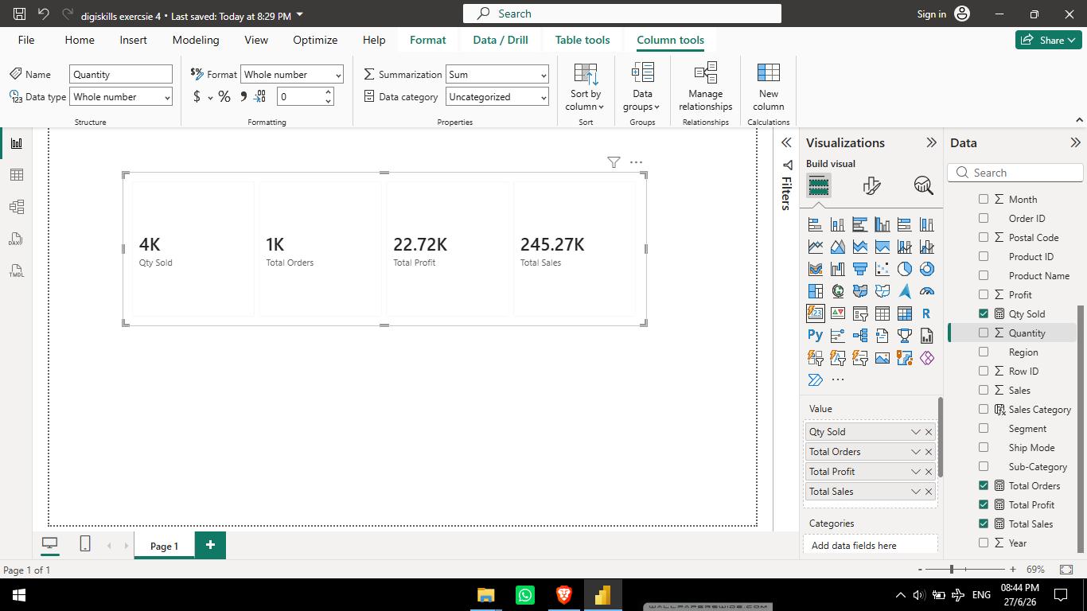

Task 2:
Create a Line Chart showing Monthly Sales Trends. Use the Order Date columns to create a proper date hierarchy. Display Sales on the Y-axis and Order Date on the X-axis. (2-Marks)
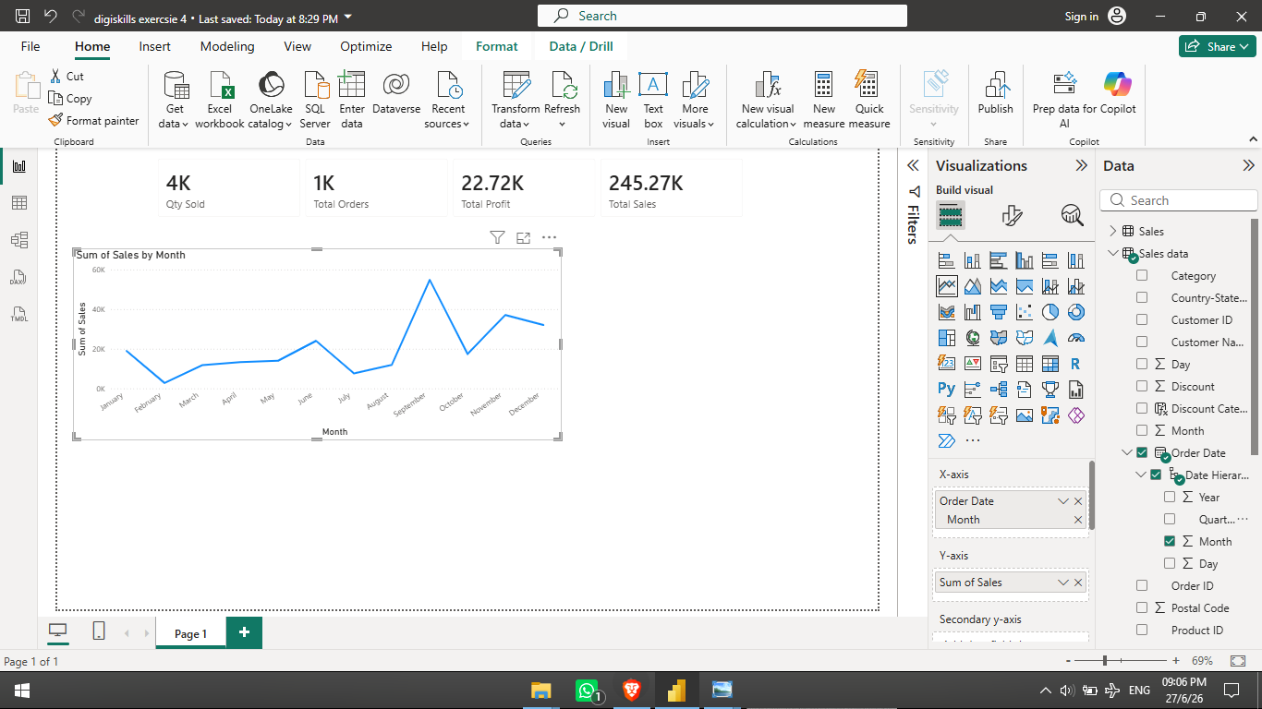

Task 3:
Create a Clustered Bar Chart showing Total Sales by Category (e.g., Technology, Furniture, Office Supplies). Sort the chart from highest sales to lowest. (1-Marks)
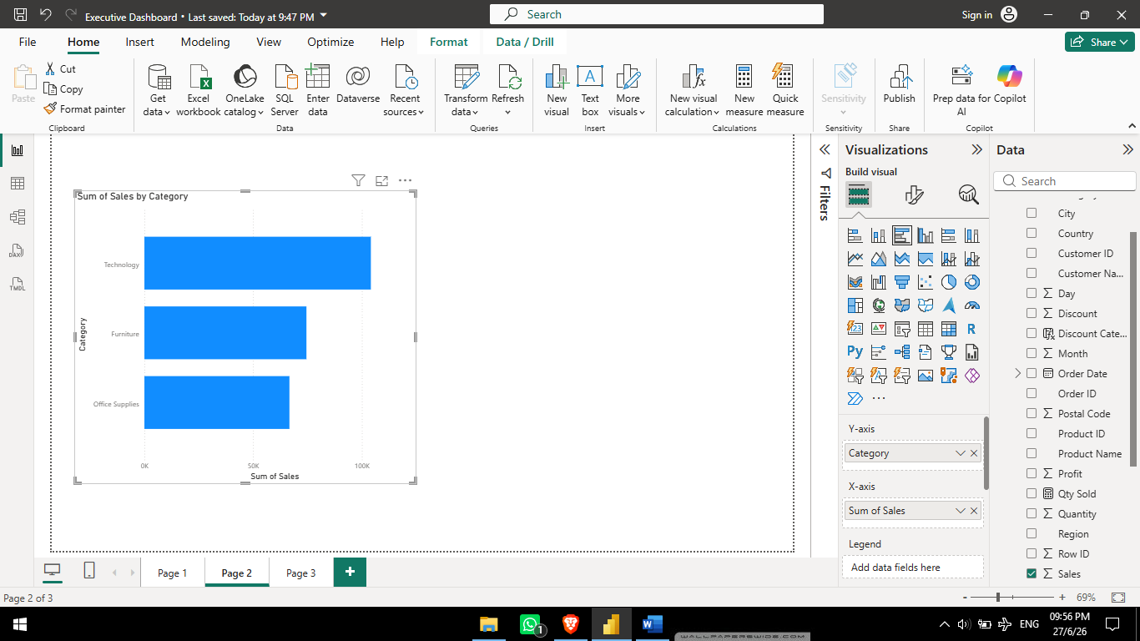

Task 4
Create a Map Visualization showing Total Sales by State. Larger bubbles should represent higher sales. (1-Marks)
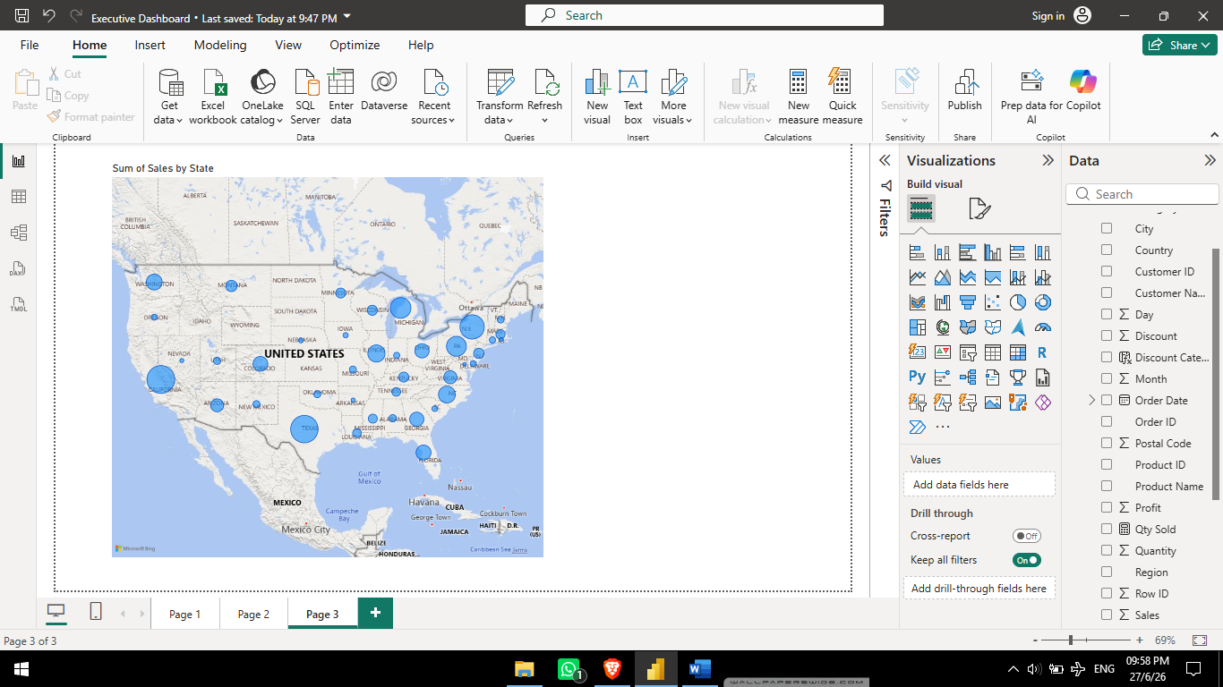

Task 5
Add Slicers for the following fields to make the dashboard interactive: (2-Marks) • Segment (e.g., Consumer, Corporate, Home Office) • Region
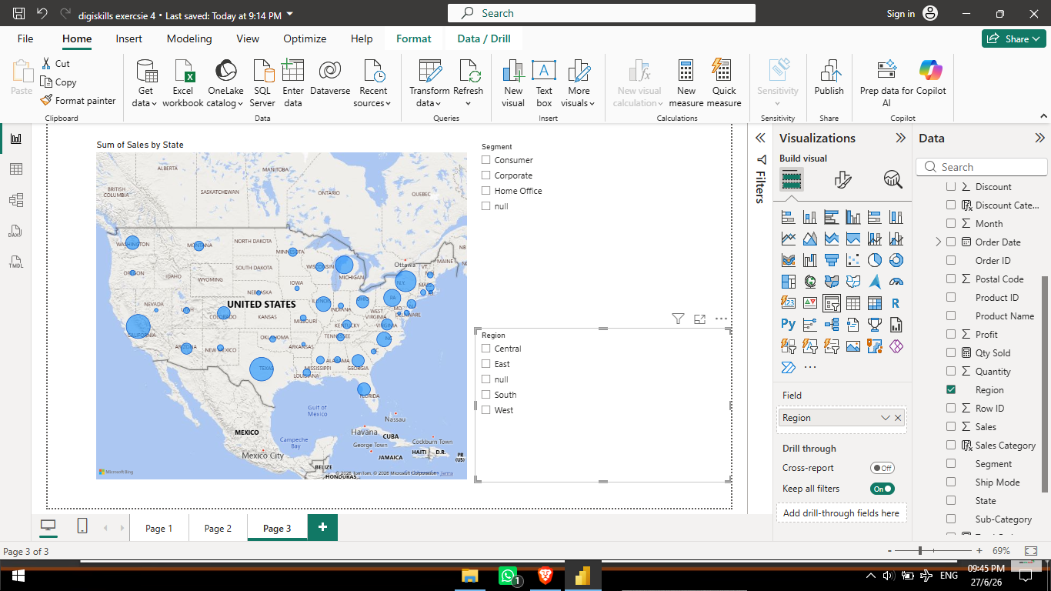

Task 6
Create a Complete Executive Dashboard – Arrange all the above visuals (Q1 to Q 5) on a single Power BI page named "Executive Dashboard” with any attractive theme. (2-Marks)
